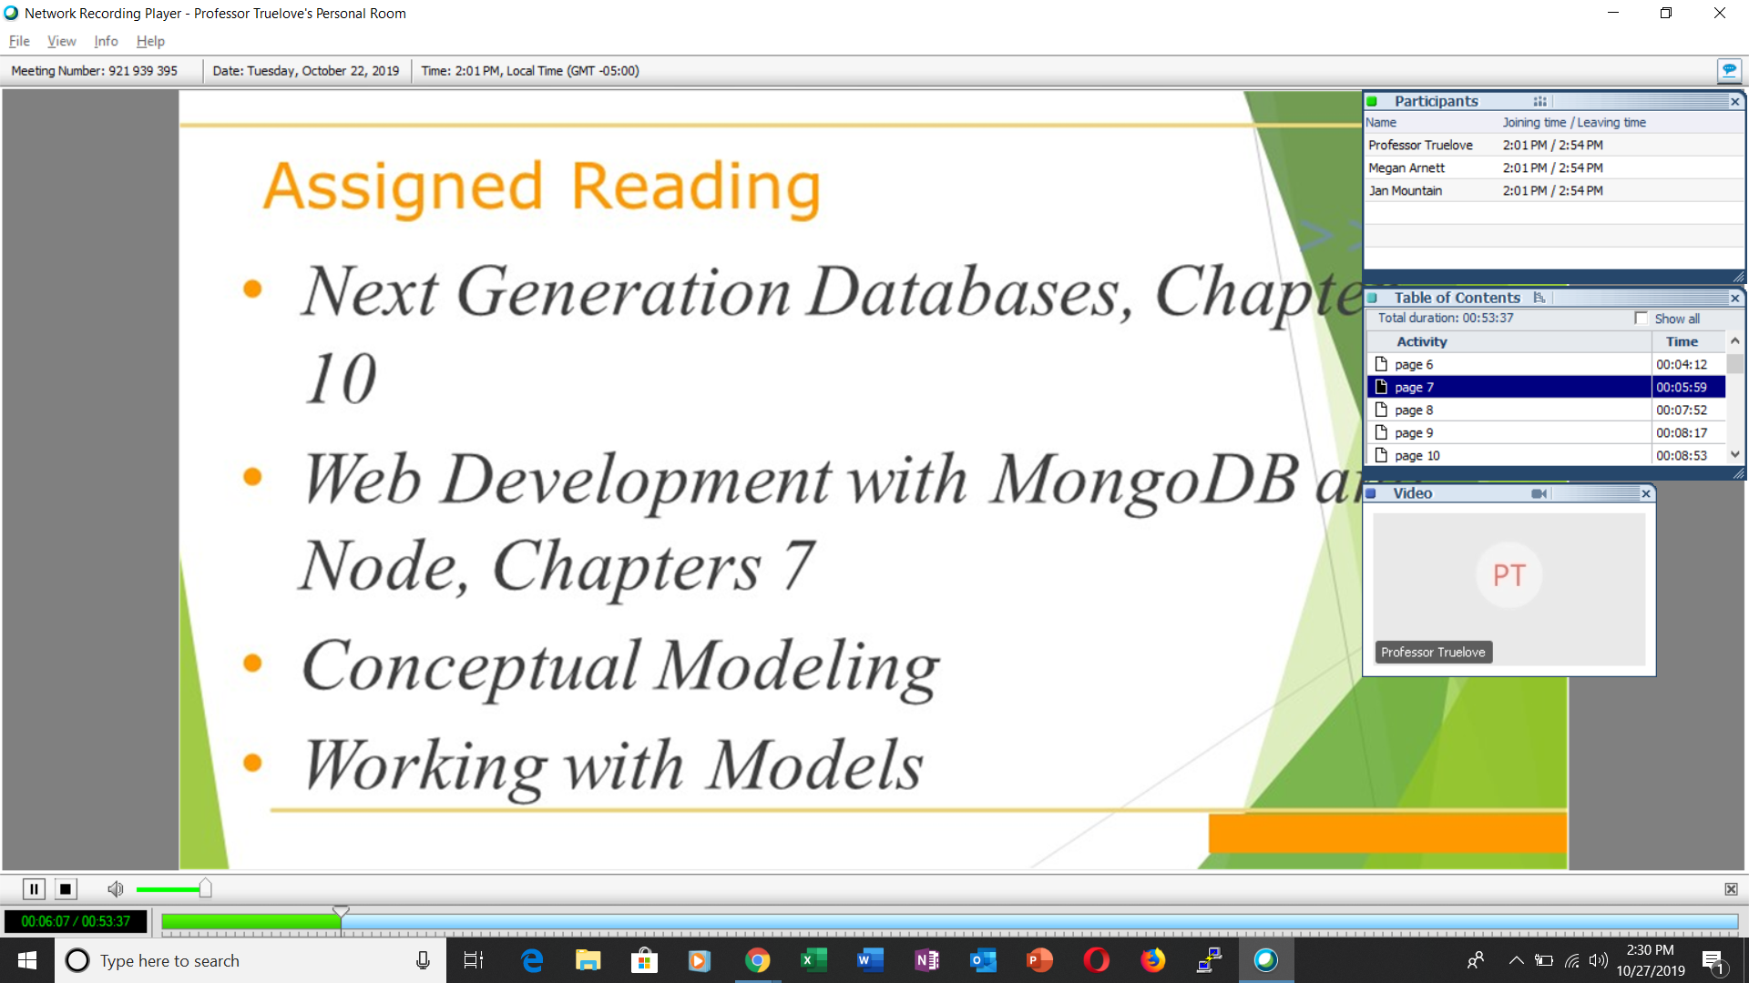

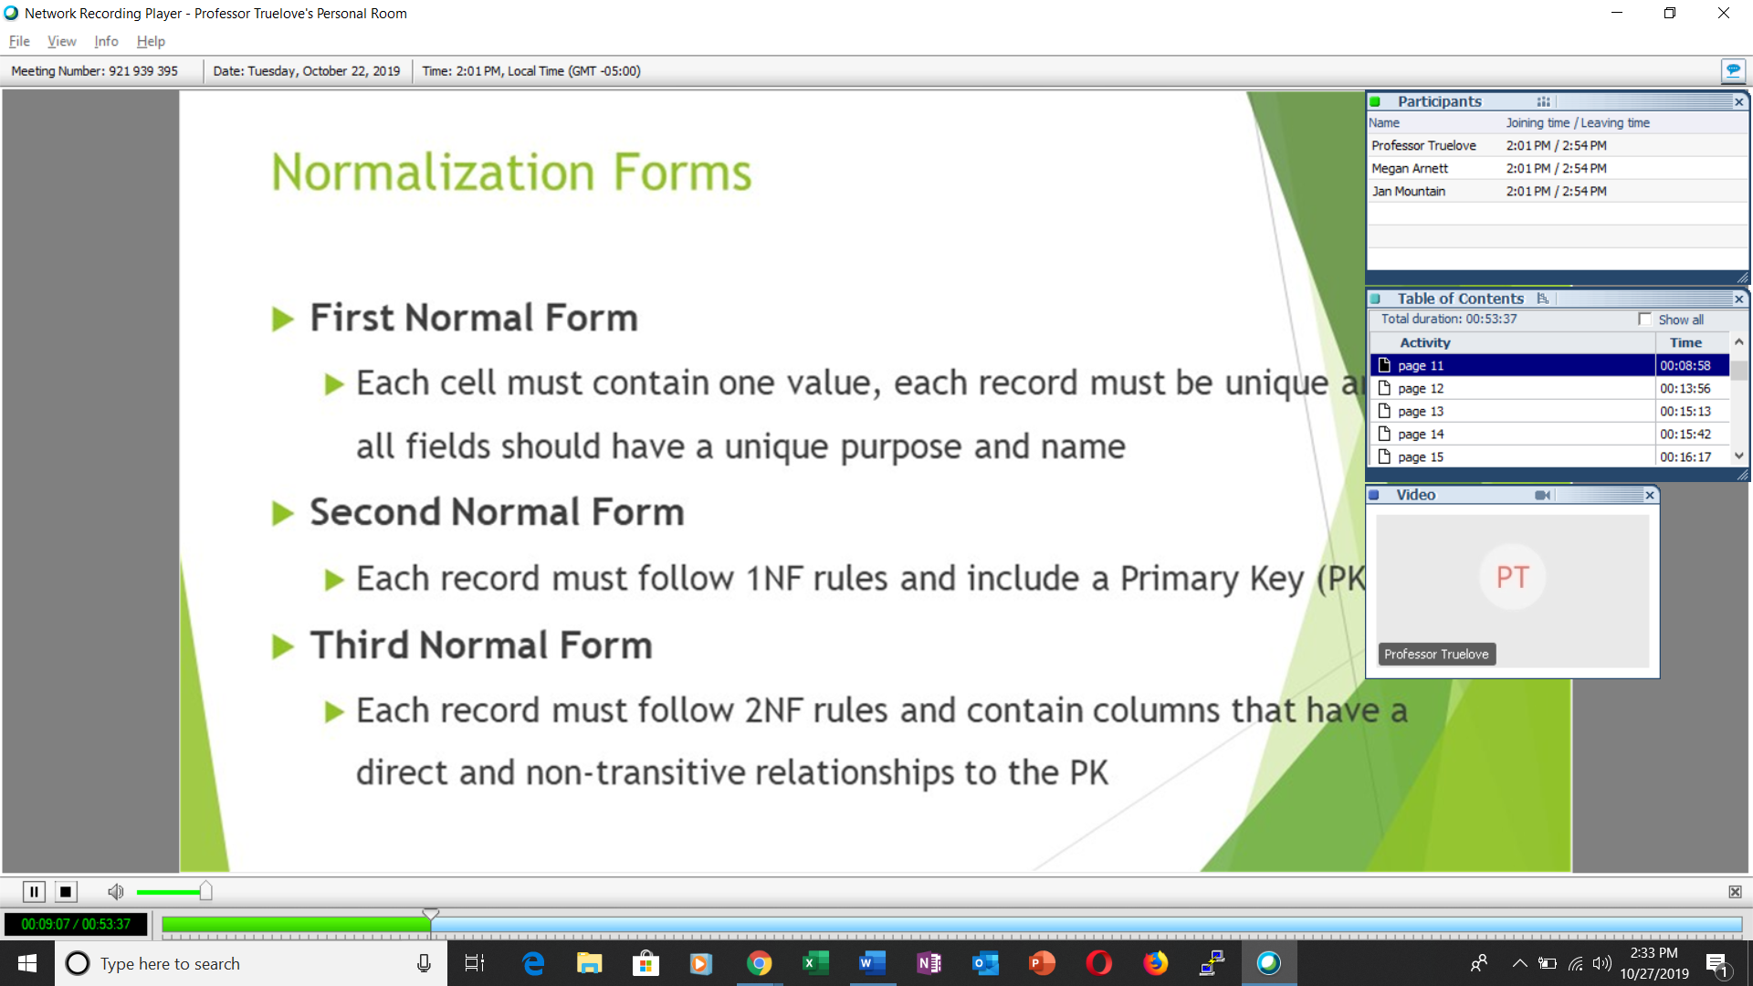

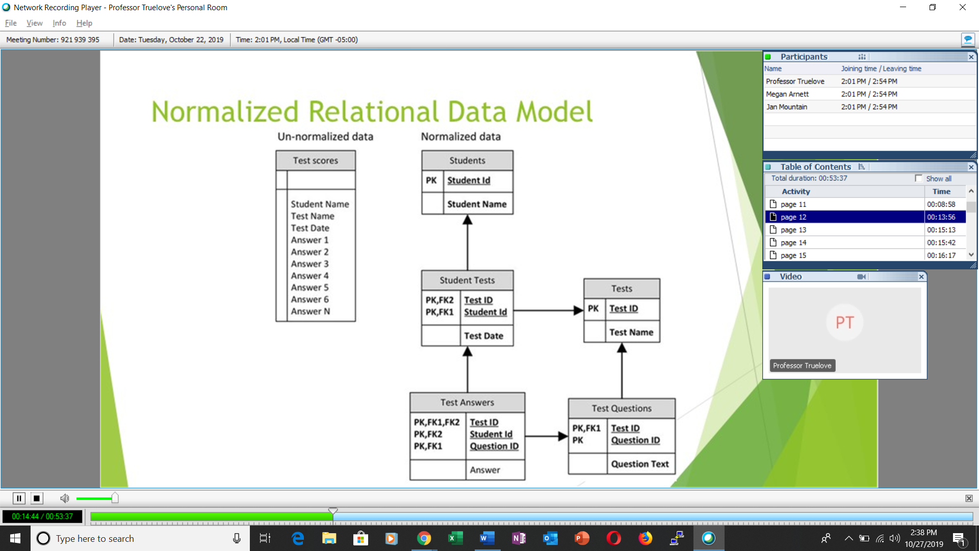

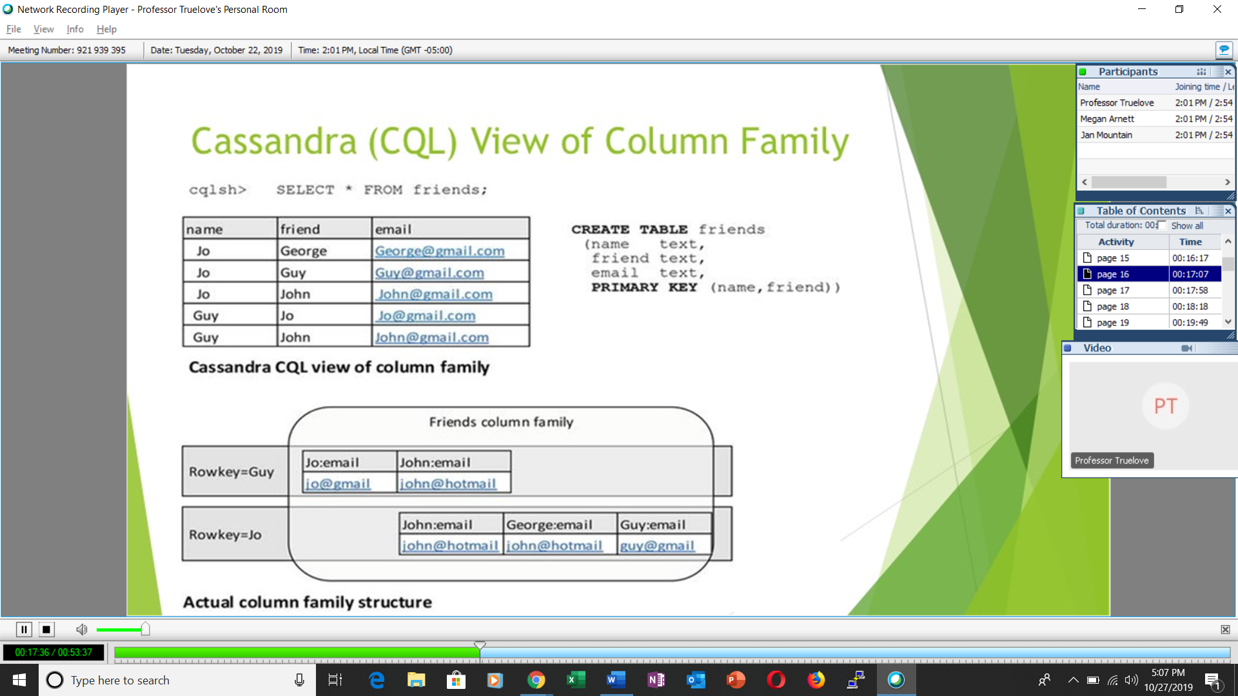

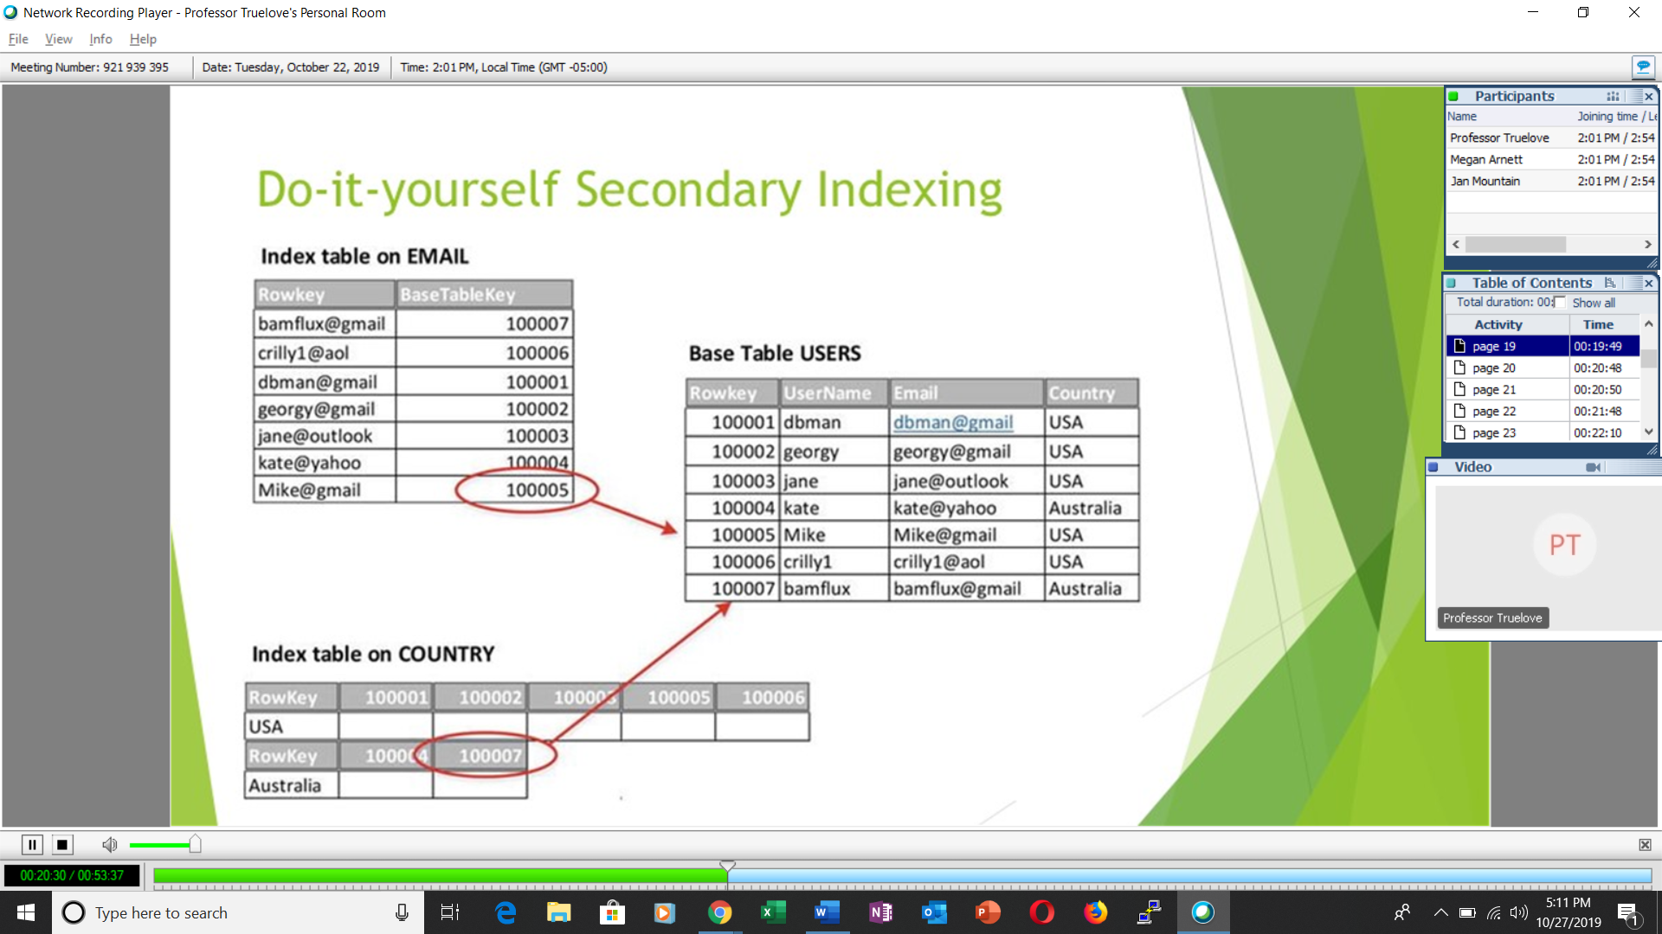

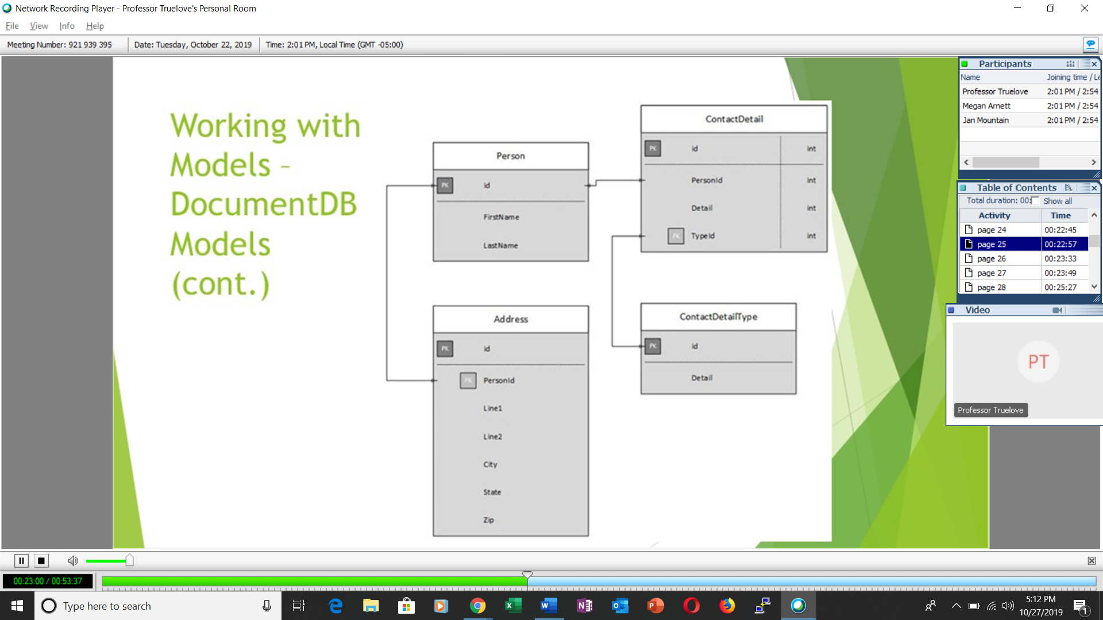



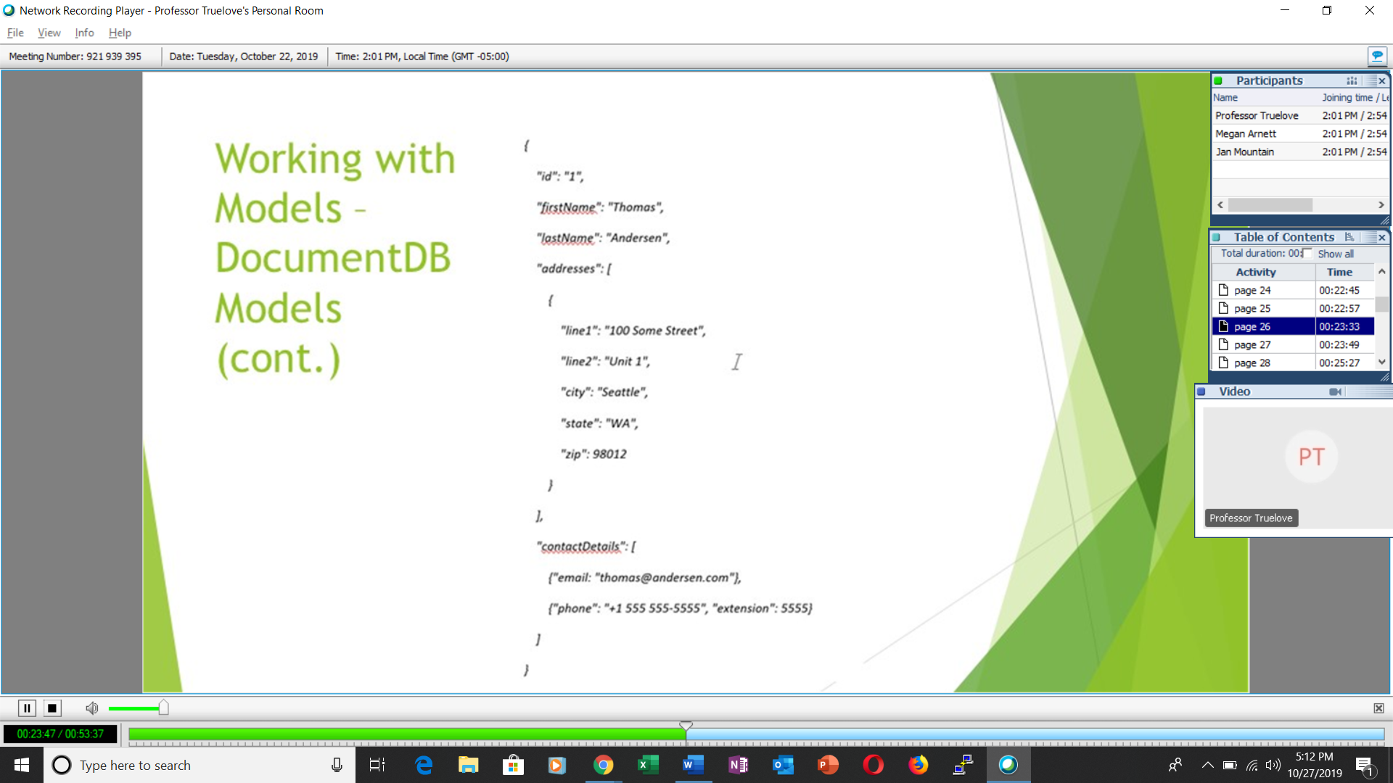

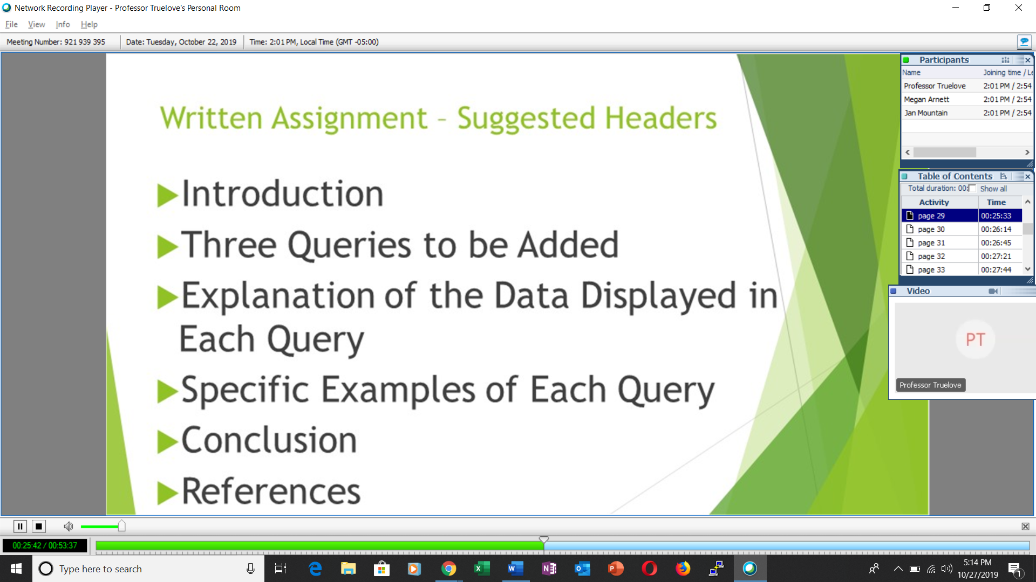



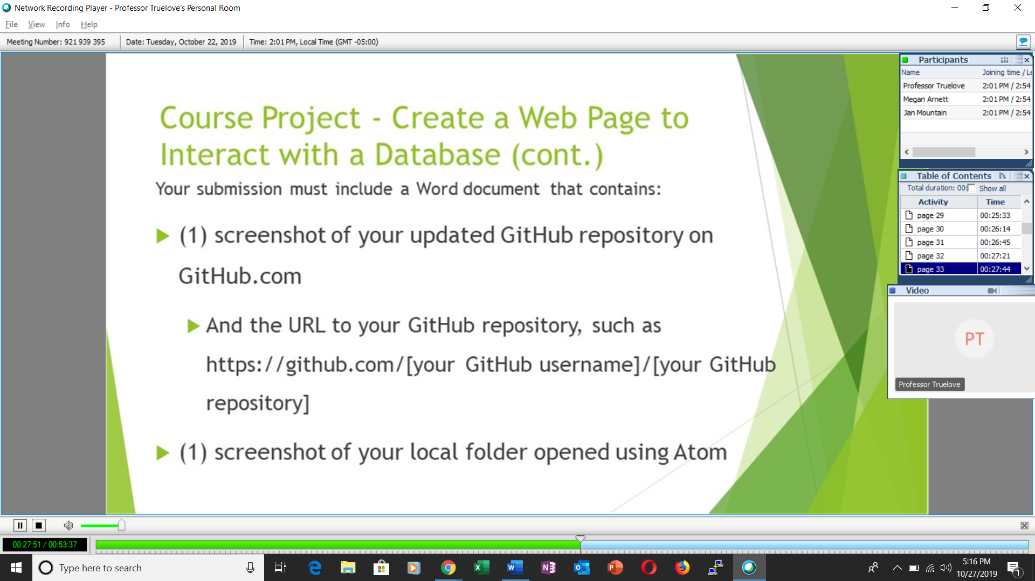

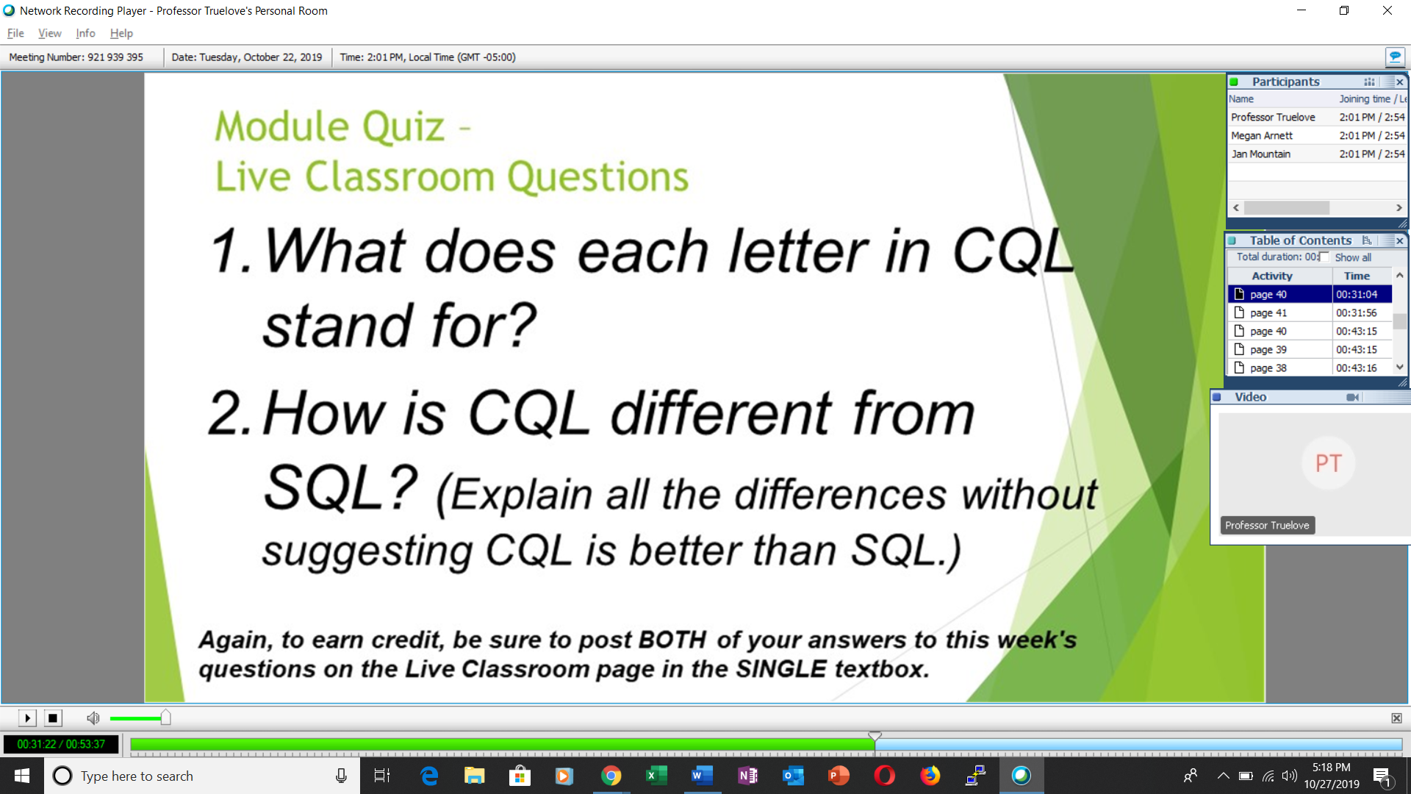

CQL stands for Cassandra Query Language.

Cassandra is responsible to deal with unstructured types of data. SQL as a type of RDMS only deals with structured types of data. Cassandra handles all sorts of data simultaneously. Accordingly, it deals with images, videos, sound and many more. SQL covers a particular type of data only. Accordingly, it handles data consisting of characters, texts, and numbers. Cassandra is able to handle data in bulk or a high volume of data that too in a simultaneous way. SQL handles data of moderate volume and that too at any particular instant.